UML
Lab Book

Document Revision History

Date | Revision No. | Author | Summary of Changes
18-Dec-2008 | 0.1D | Veena Deshpande | Creation
22-Dec-2008 |  | CLS team | Review
Jan-2009 | 1.0 | Veena Deshpande | Baselined
8 May 2009 | 1.1 | Veena Deshpande | Updated for including comments related to tool usage for Labs.
20-May-11 | 1.2 | Latha S | Added some more UML exercises , Added STARUML points needed to work on the UML exercises
04-Apr-15 | 1.3 | Kavita Arora | Made changes as per revised TOC

Table of Contents
Document Revision History 2
Table of Contents 3
Getting Started 4
Overview 4
Setup Checklist for UML 4
Instructions 4
Learning More (Bibliography) 4
UML Problem Statement/ Case Study 5
Overview – Banking System 5
Lab 1. Dynamic View Diagrams – Use Case Diagrams 6
1.1: Interpret Use Case Diagram 6
1.2: Create Use Case Diagram 7
Lab 2. Dynamic View Diagrams – Activity Diagrams 8
2.1: Interpret Activity Diagram 8
2.2: Create Activity Diagram 9
Lab 3. Dynamic View Diagrams – Sequence Diagrams 10
3.1: Interpret Sequence Diagram 10
3.2: Create Sequence Diagram 11
Lab 4. Some More Dynamic View Diagrams – State Chart Diagrams 12
4.1: Interpret State Chart Diagram 12
4.2: Create State Chart Diagram 13
Lab 5. Static View Diagrams – Class Diagrams 14
5.1: Interpret Class Diagram 14
5.2: Create Class Diagram 15
Lab 6. General and Extension Mechanisms 16
6.1: Identify approaches to extend UML 16
Appendices 17
Appendix A: Table of Figures 17

Getting Started

Overview
This lab book comprises of assignments to be done for Unified Modeling Language (UML). The course is focused towards understanding Object Oriented Concepts and understanding UML diagrams with some exposure to creating diagrams which are closely related to developer roles – class diagrams, sequence diagrams, activity diagrams.
It is recommended to get familiar with STARUML – an open source modeling tool. Instructor would give a demo of the tool. Participants would be expected to explore the tool and model the lab assignment diagrams using the tool.

Setup Checklist for UML

- STARUML to be available on all machines.

Instructions

- Specified for each of the individual assignments.

Learning More (Bibliography)

- Applying UML – Advanced Applications by Rob Pooley , Pauline Witcox
- UML User’s Guide by Grady Booch, Ivar Jacobson and James Rambaugh

UML Problem Statement/ Case Study

Overview – Banking System

A well-known bank desires to build a process of account maintenance of savings and current accounts. The savings and the current account are however maintained in different sources (databases). The system should have the online capabilities to cater to requirements viz.
- View Account Balance & details (Both Current & Savings.
- View Account details (should have only last 10 transactions)
- View Statements for the account (month-wise)
- Request for Address Changes
- Transfer requests from Savings to current account (User should be able to transfer funds amongst the current and savings account

The default view for all users is View Account Balance.

- Dynamic View Diagrams – Use Case Diagrams

Goals | - Interpret Use Case Diagram  - Create Use Case Diagram
Time | 30 minutes

1.1: Interpret Use Case Diagram
Study the Use Case Diagram and answer the questions given below.
Cur_ICENTURIAN
View Account
Summary
View Account Details
View Statements
Request Address Change
Activate Destination Account
Account Holder
Email System
Transfer Funds
<<extend>>
Sav_ICENTURIAN
Create Destination Account
<<extend>>
Login
Figure 1: Use Case Diagram

Questions:
  - Name the actors.
  - Why is the Email System considered as an actor for this system?
  - How would the above diagram be different if the data sources were designed as part of the application?
  - Name the use cases that can be invoked by Account Holder.
  - Which use case has extension points? What are the extended use cases?
  - Does this online system allow the use to pay insurance premiums? If yes, which is the use case? If no, how can the diagram be changed to include that?

1.2: Create Use Case Diagram
[This assignment is to be done in groups of 2 to 4 participants.]

- Draw the Use Case diagram for the following scenario. Discuss your diagram with other groups.

Visitors can browse the catalog of an online book store and check for availability for a book.
Registered customers can browse, search and place orders. S/He can also cancel the placed order. Placed orders are fulfilled only after the credit card details entered by the customer are validated by a third party payment gateway. The shipping details of the fulfilled orders are sent to Shipping Agent. The Sales report is sent to the CEO every month.

- Consider any other online application of your choice. For this application, identify actors and use cases. Draw the use case diagram. Discuss your diagram with other groups.

Hint: Consider online applications such as Hotel Reservations, CD Rental Library and so on.

- Dynamic View Diagrams – Activity Diagrams

Goals | - Interpret Activity Diagram  - Create Activity Diagram
Time | 30 minutes

2.1: Interpret Activity Diagram
Study the activity diagram and answer the questions given below.
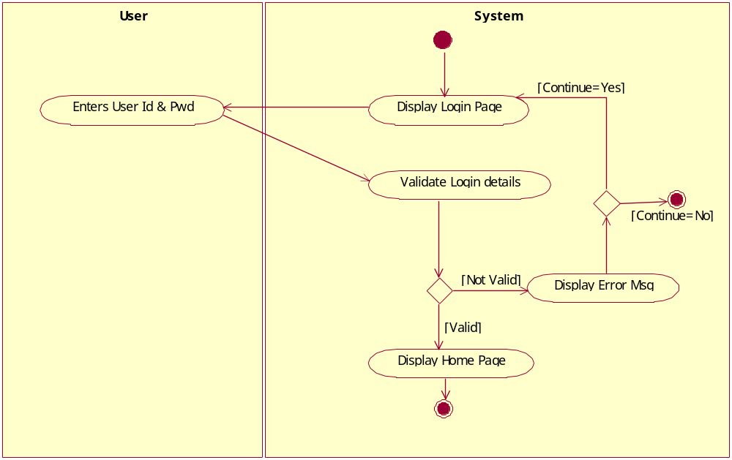
Figure 2: Activity Diagram

Questions:
  - Refer 1.1. Which use case do you think this activity diagram is describing?
  - Name the swimlanes that you find in this diagram.
  - Consider the following change to the use case: Only 3 attempts are permitted to enter valid user id and password. Make appropriate changes to this diagram.

2.2: Create Activity Diagram
[This assignment is to be done in groups of 2 to 4 participants.]

- For the system considered in 1.2 A, draw an activity diagram for the purchase use case. Discuss your diagram with other groups. You can use the following for guidelines for the workflow associated with this use case.

Registered customer can browse and select items, add it to shopping cart, and when he has finished shopping, proceed to billing.

- For the system considered in 1.2 B, draw an activity diagram for a use case of your choice. Discuss your diagram with other groups.

- Dynamic View Diagrams – Sequence Diagrams

Goals | Interpret Sequence Diagram
Time | 10 minutes

3.1: Interpret Sequence Diagram
A. Study the sequence diagram. This illustrates retrieval of account details of a customer from an external data source. Answer the questions given below.

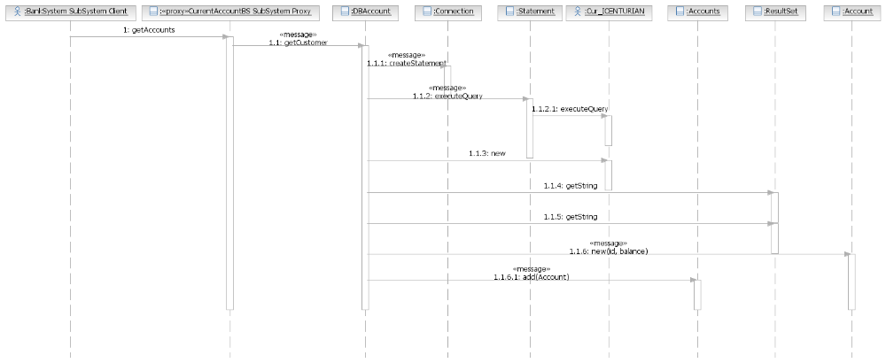
Figure 3: Sequence Diagram

Questions:
  - Name any 3 objects that are part of this diagram.
  - Which is the external data source from where the data is being retrieved?
  - If a class called “Statement” is coded considering this sequence diagram, what operation must be part of the “Statement” class?
  - Does this sequence diagram model error conditions? If yes, what are they? If no, what could be the error conditions and how would you model them?

B. Study the sequence diagram given below and answer the following questions.
  - The operation getAvailableReports() belongs to the class FinancialAnalyst. TRUE /FALSE
  - What methods would be implemented by the class ReportingSystem ?
  - What is the return value of the method getAvailableReports ?
  - Who is responsible for calling the operation determineAvailableReports() ?

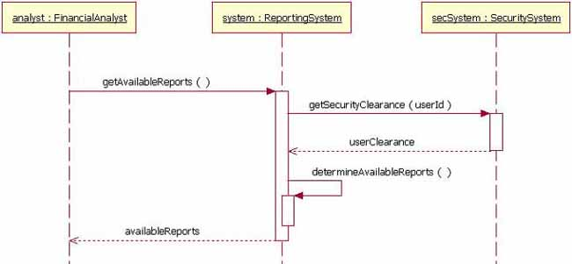

3.2: Create Sequence Diagram
Draw the sequence diagram for login module for Registered customers:
  - User enters id and password on the Form and clicks the submit button.
  - The OnSubmit() method is invoked.
  - The OnSubmit() method instantiates the LoginBO object. It calls the IsValidLogin Method and passes the id and password.
  - Two methods, IsValidID() and IsValidPWD() of LoginBO object, are executed within the LoginBO object.
  - If one of the methods returns false, then false is returned by IsValidLogin()
  - If both methods are returning true, then LoginBO instantiates the LoginDAO object. It calls the ValidateLogin() method of the DAO and passes the id and password.
  - The LoginDAO’s checks with the database and returns true /false accordingly.
  - The return value of DAO is returned by the BO object to the presentation layer i.e. to the Form.

Additional Exercise: Add the feature that the user is allowed to try the above functionality 5 times.
- Some More Dynamic View Diagrams – State Chart Diagrams

Goals | - Interpret State Chart Diagram  - Create State Chart Diagram
Time | 20 minutes

4.1: Interpret State Chart Diagram
Study the state chart diagram. This illustrates the various states in which an “Account” object can be in. Answer the questions given below.

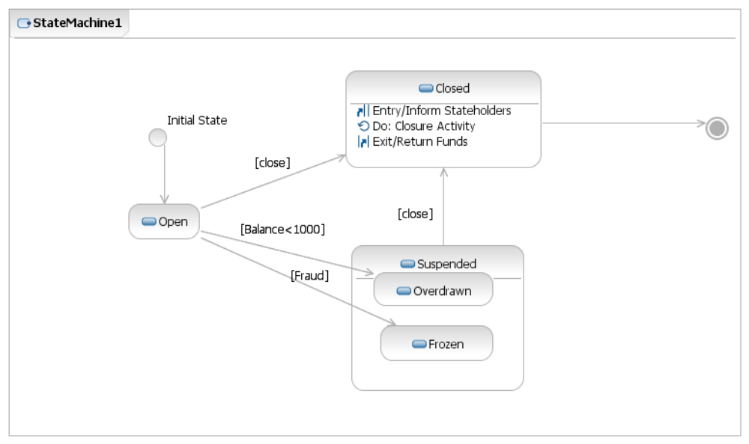

Figure 4: State Chart Diagram

Questions:
  - What are the start and end states indicated on this diagram.
  - Are there any states depicting “State-Sub state” relationships? Which are these states?
  - Which states depicts entry action, exit action and internal activity? What are these actions/activities?
  - Under what conditions does the Account go into Suspended state?

4.2: Create State Chart Diagram
Draw a state chart diagram which illustrates the states in which text style can be in a MS-word document. Indicate appropriate transitions.

Hint: Consider that the font style and size of the text remains same. But the text can be in normal style, bold, italics and so on. Are combinations also possible? For example: Bold and Underlined?

- Static View Diagrams – Class Diagrams

Goals | - Interpret Class Diagram  - Create Class Diagram
Time | 20 minutes

5.1: Interpret Class Diagram
Study the class diagram and answer the questions given below.

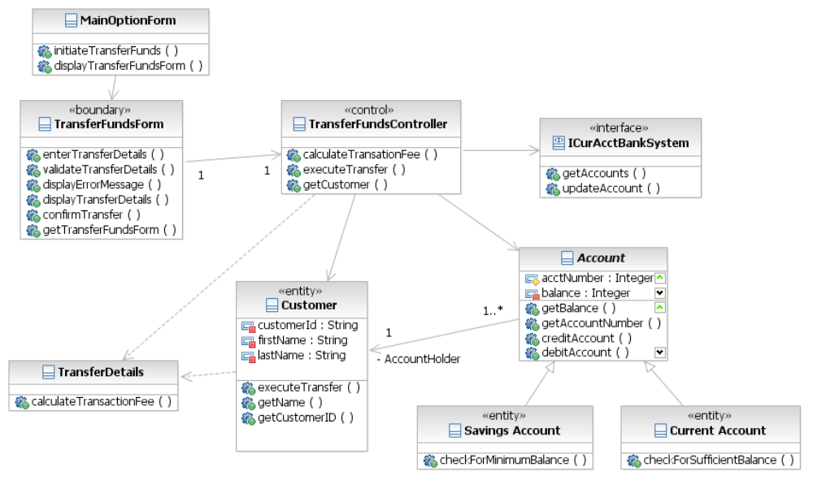
Figure 5: Class Diagram

Questions:
  - Name all the classes that are part of this diagram.
  - Name the attributes defined for the “Customer” class.
  - Name the operation defined for the “TransferFundsController” class.
  - The following relationships are depicted amongst which classes?
    - Generalization
    - Dependency
    - Association
  - Can a customer hold multiple accounts in the bank? Are joint accounts permitted as per this diagram?
  - What needs to change in the above diagram if we wanted to depict the relationship that “Customer has Accounts”?

5.2: Create Class Diagram
- Use the following information to create a class diagram.
- A customer class is related to an order class with an association relationship. One customer can be associated with multiple orders, but an order belongs to exactly one customer.
- Each order is composed of multiple products. Depict a composition relationship between Order class and Product class.
- A product could be assembled using several product parts. Depict a composition relationship between the Product class and Product Part class.
- There are “Gold Customers” i.e. Special customers who get better deals on orders. Illustrate class called “Gold Customer” as a special type of customer class.

- Draw the class diagram for the following using STARUML, referring to the Question 3.2. The following guidelines are given
- LoginBO
 | Attributes | Methods
Public |  | Default constructor
Public |  | IsValidLogin takes 2 string as arguments and returns boolean
Private |  | GetUserName takes 2 string and returns String
Private |  | IsValidUser takes string as argument and returns boolean
Private |  | IsValidPWD takes string as argument and returns boolean
- LoginDAO
 | Attributes | Methods
Public |  | Constructor which takes string as an argument
Public |  | IsValidLogin takes 2 string as arguments and returns boolean
Private | Connection object (user defined) | GetConnection takes no arguments and returns a connection reference

- LoginBO has a dependency relation with LoginDAO.

- General and Extension Mechanisms

Goals | Identify Extension Mechanisms
Time | 5 minutes

6.1: Identify approaches to extend UML
Revisit the diagrams given in the previous labs to answer the questions given below.
  - Name the extension mechanisms you find in the Use Case Diagram and Deployment Diagram.
  - Name some stereotypes that you find on the Class Diagram.
  - Name some adornments that you find on the Class Diagram.
  - Do you find any Notes being depicted on any of the diagrams? If yes, in which diagrams?

Appendices

Appendix A: Table of Figures

Figure 1: Use Case Diagram 6
Figure 2: Activity Diagram 8
Figure 3: Sequence Diagram 10
Figure 4: State Chart Diagram 12
Figure 5: Class Diagram 14

